Attachment B

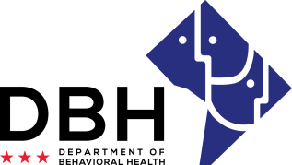
Faith Based Organizations: Connecting DC Residents with Behavioral Needs to Clinical Services and Treatment During COVID 19
RFA # RM0FBS121820

Intent to Apply Notification
Due Date: Wednesday, December 23, 2020, 5:00 p.m. ET

TO: Department of Behavioral Health, Grants Management Office
www.DBH.Grants@dc.gov

FROM:
Name of Organization

RE: Intent to Apply for Faith Based Organizations: Connecting DC Residents with Behavioral Needs to Clinical Services and Treatment During COVID 19

Organization Address:
Contact Person/Title:
Contact Person Telephone Number:
Contact Person Email:

This notification serves as intent to apply for the abovementioned Request for Application. The notification is due Wednesday, December 23, 2020 to DBH.Grants@dc.gov Notifications are to be sent to this email address only and will not be received via telephone, fax, or in-person.

I am also confirming attendance at the mandatory pre-application conference being held Tuesday, December 22, 2020.

Webinar (ONLY): ☐Yes # Attendees:

Print Name Date

Signature

