Attachment I

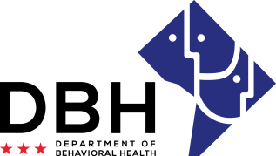
Recovery Residences
RFA# RM0 RR112219
Intent to Apply Notification
Due Date: Monday, December 2, 2019

TO: Department of Behavioral Health, Grants Management Office
www.dbh.grants@dc.gov

FROM:
Name of Organization

RE: Intent to Apply for
[Insert RFA Title]
Multiple competitions:
Competition #1 – Level I or II Recovery Residences ☐Yes ☐No
Competition #2 – Opioid Specific Residences ☐Yes ☐No
Organization Address:
Contact Person/Title:
Contact Person Telephone Number:
Contact Person Email:

This notification serves as intent to apply for the abovementioned Request for Application. The notification is due December 2, 2019 to dbh.grants@dc.gov Notifications are to be sent to this email address only and will not be received via telephone, fax, email (other than address noted) or in-person.

I am also confirming attendance at the mandatory pre-application conference being held December 6, 2019.
In-Person: ☐Yes ☐No #Attendees:
Webinar: ☐Yes ☐No

Print Name Date

Signature

