Attachment A (Competition 4)
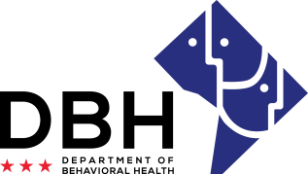
District of Columbia Opioid Response (DCOR) Grant Opportunities
RFA # RM0 DOR012221

Notice of Eligibility and Experience Requirements for Competition 4: Hospital-Based Naloxone Training and Technical Assistance

Eligibility Requirements
Applicants must meet the stated eligibility and performance requirements in the RFA. Please describe your organization’s eligibility in the applicable box below. You may include supporting documents.

1. Eligible entities who can apply for grant funds under this RFA have/are:
Able to enter into an agreement with DBH requiring compliance with all governing federal and District of Columbia laws and regulations, including Substance Use Disorders and Mental Health Grants (22-A DCMR Chapter 44).

Justification:

At least two (2) years’ experience providing training and/or technical assistance to large, urban hospitals.

Justification:

Demonstrated knowledge of the financial, legal, and regulatory landscape surrounding naloxone.

Justification:

Experience Requirements
2. Eligible entities who can apply for grant funds under this RFA should have the following experience:

Experience managing local (District of Columbia) or federal grants.

Justification:

Demonstrated ability to start work within thirty (30) calendar days of award.

Justification:

A functioning accounting system that is operated in accordance with generally accepted accounting principles.

Justification:

