Attachment A (Competition 1)
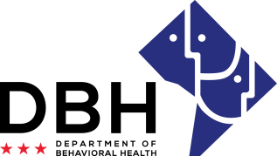
District of Columbia Opioid Response (DCOR) Grant Opportunities
RFA # RM0 DOR012221

Notice of Eligibility and Experience Requirements for Competition 1: Faith-Based Prevention, Outreach, and Recovery

Eligibility Requirements
Applicants must meet the stated eligibility and performance requirements in the RFA. Please describe your organization’s eligibility in the applicable box below. You may include supporting documents.

1. Eligible entities who can apply for grant funds under this RFA are/have:
Able to enter into an agreement with DBH requiring compliance with all governing federal and District of Columbia laws and regulations, including Substance Use Disorders and Mental Health Grants (22-A DCMR Chapter 44).

Justification:

Faith-based organizations located in the District of Columbia.

Justification:

501(c)(3) non-profit status, or have the ability to enlist the services of a fiscal agent that meets this criteria to apply for the funding on behalf of the applicant organization.

Justification:

Active Charitable Solicitation license from DC Department of Consumer and Regulatory Affairs (DCRA).

Justification:

Experience Requirements
2. Eligible entities who can apply for grant funds under this RFA should have the following experience:
Demonstrated ability to start work within seven (7) days of award.

Justification:

If a current or former DBH grantee, the ability to prove compliance with all past or ongoing grant requirements (e.g., proof that all milestones have been met, data reports submitted, etc.).

Justification:

