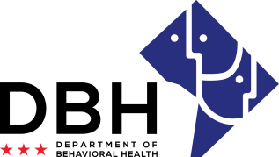
Faith Based Organizations: Connecting DC Residents with Behavioral Needs to Clinical Services and Treatment During COVID 19
RFA # RMO FBS082820

Notice of Eligibility and Experience Requirements
Applicants must meet the stated eligibility and experience requirements in the RFA. Please describe your organization’s eligibility and experience in the applicable boxes below. You may include supporting documents.

Eligibility Requirements

1. Eligible entities who can apply for grant funds under this RFA are:
Faith-based organizations located in the District of Columbia (DC).
Justification:

501(c)(3) non-profit status, or the ability to enlist the services of a fiscal agent that meets this criteria to apply for the funding on behalf of the applicant organization.
Justification:

Active Charitable Solicitation license from DC Department of Consumer and Regulatory Affairs (DCRA).
Justification:

Experience Requirements
2. Eligible entities who can apply for grant funds under this RFA should have the following experience:
Shall be a faith-based organization located in the District of Columbia with experience providing outreach and engagement, such as providing information to District of Columbia communities regarding public health issues, on behavioral health issues to the faith-based community in the District of Columbia.

Justification:

Shall demonstrate experience through examples of providing community education to reduce the stigma and fear associated with supporting individuals with behavioral health needs, such as feelings of depression, symptoms of serious mental illnesses like schizophrenia or bi-polar disorder and/or an addiction to a substance to District of Columbia residents.
Justification:

Shall demonstrate the faith-based organization possesses at least 4 years of experience providing pastoral counseling and supports for individuals who have a diagnosis of a mental health and/or substance use disorder.
Justification:

