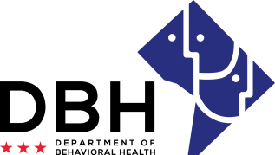
DC Opioid Response (DCOR) Prevention Grant for Ward 3
RMO DCOR022820

Notice of Eligibility and Experience Requirements

Eligibility Requirements
Applicants must meet the stated eligibility and performance requirements in the RFA. Please describe your organization’s eligibility in the applicable box below. You may include supporting documents.

1. Eligible entities who can apply for grant funds under this RFA are:
District of Columbia organizations who have provided programming and/or collaborated with agencies on substance abuse prevention agencies in Ward 3
Justification:

501(c)(3) non-profit status, Community Prevention Networks (CPNs), or community based organizations focused on substance use prevention
Justification:

Eligible to participate in District-funded programs (not disbarred) as evidenced by an exclusion verification
Justification:

Is not currently a recipient of two or more DBH DCOR sub-grants
Justification:

Is not a current DC Prevention Center (DCPC) or DCPC parent agency
Justification:

